Environmental Monitoring Program - Sampling Procedure Lesson

- Procedures
  - Sampling Plan is a systematic way to assess the microbiological quality of food lots. A “lot” refers to a batch of products manufactured under the same conditions at the same time. During sampling, the samples should be taken from the lot independently and randomly. In developing a sampling plan, a number of factors should be taken into consideration, including properties of food, production processes, storage conditions of the final products, associated risks, targeted consumers, and practical limitations. Each food product should be considered individually.
    - Types of Sampling Designs
      - Two-class attributes plan- Under this plan, sample(s) is (are) taken from the lot and tested. As only one microbiological limit, “m,” is involved in this plan, therefore, two classes of attributes, ≤ m & > m, could be identified. The maximum allowable number of the sample(s) that yielded unsatisfactory test results is represented by “c”. The lot will be accepted or rejected as illustrated in the following diagram:

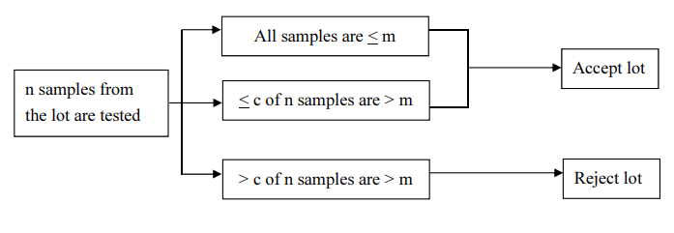
      - Three-class attributes plan- For a three-class attributes plan, two microbiological limits, m & M, are set. The microbiological limit “m” commonly reflects the upper limit of a good manufacturing practice (GMP). The criterion “M” marks the limit beyond which the level of contamination is hazardous or unacceptable. The lot will be accepted or rejected as shown in the following diagram:
    - Selection of Sampling Plan
      - Decision Tree for selecting sampling plan

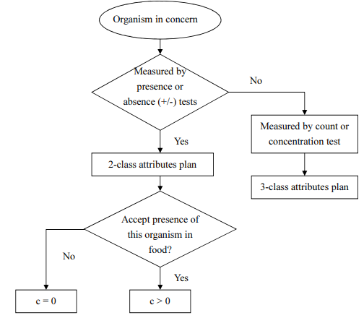
  - Sample Collection
    - Sampling Materials and PPEs
      - Sterile gloves (sizes 7 and 9 to include latex-free styles)
      - Hand sanitizers (wash and sanitize hands often during sampling)
      - Cooling medium for samples
      - Boxes or coolers
      - Labels to ID samples
      - Permanent marker
      - Flashlight Sterile metal spatulas (small) or other sterile implement to scrape debris out of cracks
      - Approved Swabbing Sponges and Sterile Swabs
      - Hair and beard restraint (disposable)
      - Hearing protection (earplugs or earmuffs)
      - Clean disposable coverall suits
      - Clean disposable booties
      - Sleeve guards (per company policy)
      - Helmet (per company policy)
      - Face mask (per company policy)
      - Approved footwear
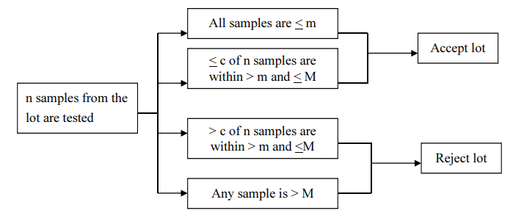
    - Sampling points
      - Raw Materials
      - Environmental Monitoring Zones
      - Finished Products
      - Water system
      - HVAC System
    - Swabbing Techniques
      - Swabbing Techniques for Sponges
        - Sample site: Sample an area that is 12” x 12” (one square foot).
        - Wipe the sponge from left to right, covering the entire square.
        - Turn the sponge over and wipe it up and down, covering the entire square.
      - Swabbing Procedure for Pre-Moistened Sponges
        - Grab the bag by the bottom and shake in a downward motion to move the sponge to the top of the bag.
        - Tear open the bag.
        - Push the sponge so that it is above the top of the bag.
        - Tear open the glove packet. Grab the glove by the cuff and place it on the sampling hand (Do not set the opened bag down.)
        - Remove the sponge from the bag with the gloved sampling hand. (Do not touch the sample bag with your gloved hand.)
        - Squeeze the bag while removing the device to make a wide opening for when the sponge will be placed back in the bag.
        - Sample the surface by pressing evenly and firmly (as if you are scrubbing) (see swabbing techniques above).
        - After completing the swabbing, place the sponge back in the sample bag. (Do not touch the sponge to the outside of the sample bag.)
        - Remove your glove.
        - Squeeze as much air out of the bag as possible. Roll the top of the bag inward and fold over the wire tabs to secure it.
        - Place the sponge bag inside another Whirl-Pak or equivalent bag and seal it as before. Both bags must be tight enough to provide both a leak-proof seal and minimal airspace during the shipment of the moistened sponge.
      - Swabbing Procedure for Sponge on A Stick
        - Break off the handle by holding the sponge in place from outside the bag and bending the handle back and forth. The sponge will drop to the bottom of the bag.
        - Discard the handle. Roll the top of the bag inward and fold over the wire tabs to secure it.
      - Swabbing Techniques for Sterile Swabs
        - Sample site: Sample an area that is about 4” x 4” (approximately 16 square inches) or 2” x 8”.
        - Swab left to right, covering the entire square.
        - Swab up and down, covering the entire square.
        - Swab diagonally, covering the entire square. Rotate the swab tip during the process and use firm pressure.
      - Swabbing Procedure for Pre-Moistened Swabs
        - Wear a fresh set of gloves and use extra caution to prevent hands/gloves from coming in contact with the stem of the swab.
        - Press the pre-labeled swab against the edge of the tube to squeeze out excess medium.
        - Remove the sterile, pre-moistened swab from the tube.
        - Carefully swab the surface (see swabbing technique above).
        - Insert the swab back in the tube so that it comes in contact with the medium and is remoistened. Press the swab against the edge of the tube to squeeze out the excess solution.
        - Re-swab the same surface by changing direction by 90 degrees.
        - Reinsert the swab to moisten. Press the swab against the inside edge of the tube to squeeze out excess medium.
        - Re-swab the same site by changing to a diagonal direction.
        - Reinsert the swab and screw down the cap. The cap must be on tight to prevent leakage.
    - Labeling
      - Collected samples should be labeled for traceability, these details include the following:
        - Sample/Material Name
        - Sampling point or Location
        - Microbiological Test to be done
        - Date and Time of swabbing

4. History
Revision No.: | Revision Date: | Description of Change: | Originator / Author Name: | Title / Department:
0 | YYYYMMDD | Original | ENTER AUTHOR NAME | ENTER TITLE / ENTER DEPARTMENT

Requirements:
- The trainee (employee/visitor) has read or received a verbal translation of all or part of the policy, procedure, method, and/or SOP for which they are being trained.
- The trainee has observed a demonstration of the task they are to perform or the procedure for which they are being trained as required.
- The trainee has demonstrated the ability to perform the task with acceptable proficiency and minimal supervision.

